# Lab 13: Deep Learning Tutorial 3

By Michael Su, Sam, Andy last modified on 6/01 2020.

## Hardware and Software Setup

Access GPU machine with ssh

**laptop $ ssh** [**[username]@140.113.xxx.xxx**](mailto:arg@140.113.xxx.xxx)

([Work Station List](https://docs.google.com/spreadsheets/d/1YSC0dBCVtI4CdffFRr6Yw_pQU_3VQ66NC2Lstz79DfU/edit))

type the passward then you will see like this

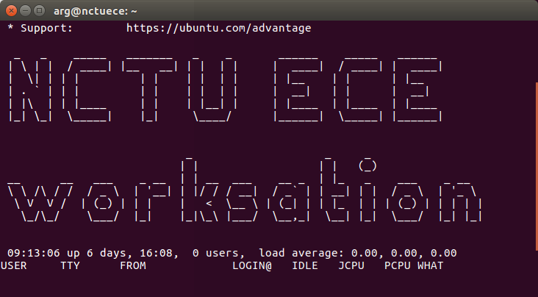-

**ws : workstation**

Clone the course repository

**ws $ cd  
ws $ cd sis_lab_all_2020 && git pull origin master**

Build dockerfile

**ws $ cd ~/sis_lab_all_2020/13-Deep_Learning_3**

**ws $ wget** [**http://aisdatasets.informatik.uni-freiburg.de/freiburg_groceries_dataset/freiburg_groceries_dataset.tar.gz**](http://aisdatasets.informatik.uni-freiburg.de/freiburg_groceries_dataset/freiburg_groceries_dataset.tar.gz) **&& tar -xvf freiburg_groceries_dataset.tar.gz**

**ws $ cd ~/sis_lab_all_2020/13-Deep_Learning_3/Dockerfiles**

**ws $ source docker_build.sh**

Run the docker and jupyter notebook

**ws $ cd .. && source docker_run.sh**

**ws $ jupyter notebook --allow-root --no-browser --ip="0.0.0.0"**

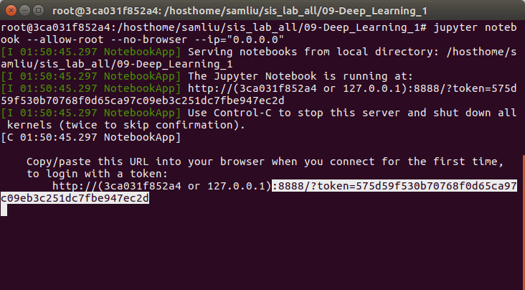

e.g. http://**[workstation_ip]**:**[port]**?token=**[xxxxx]**

Turn on the web browser and type the **workstation’s IP** and **token** from above

You will see like this

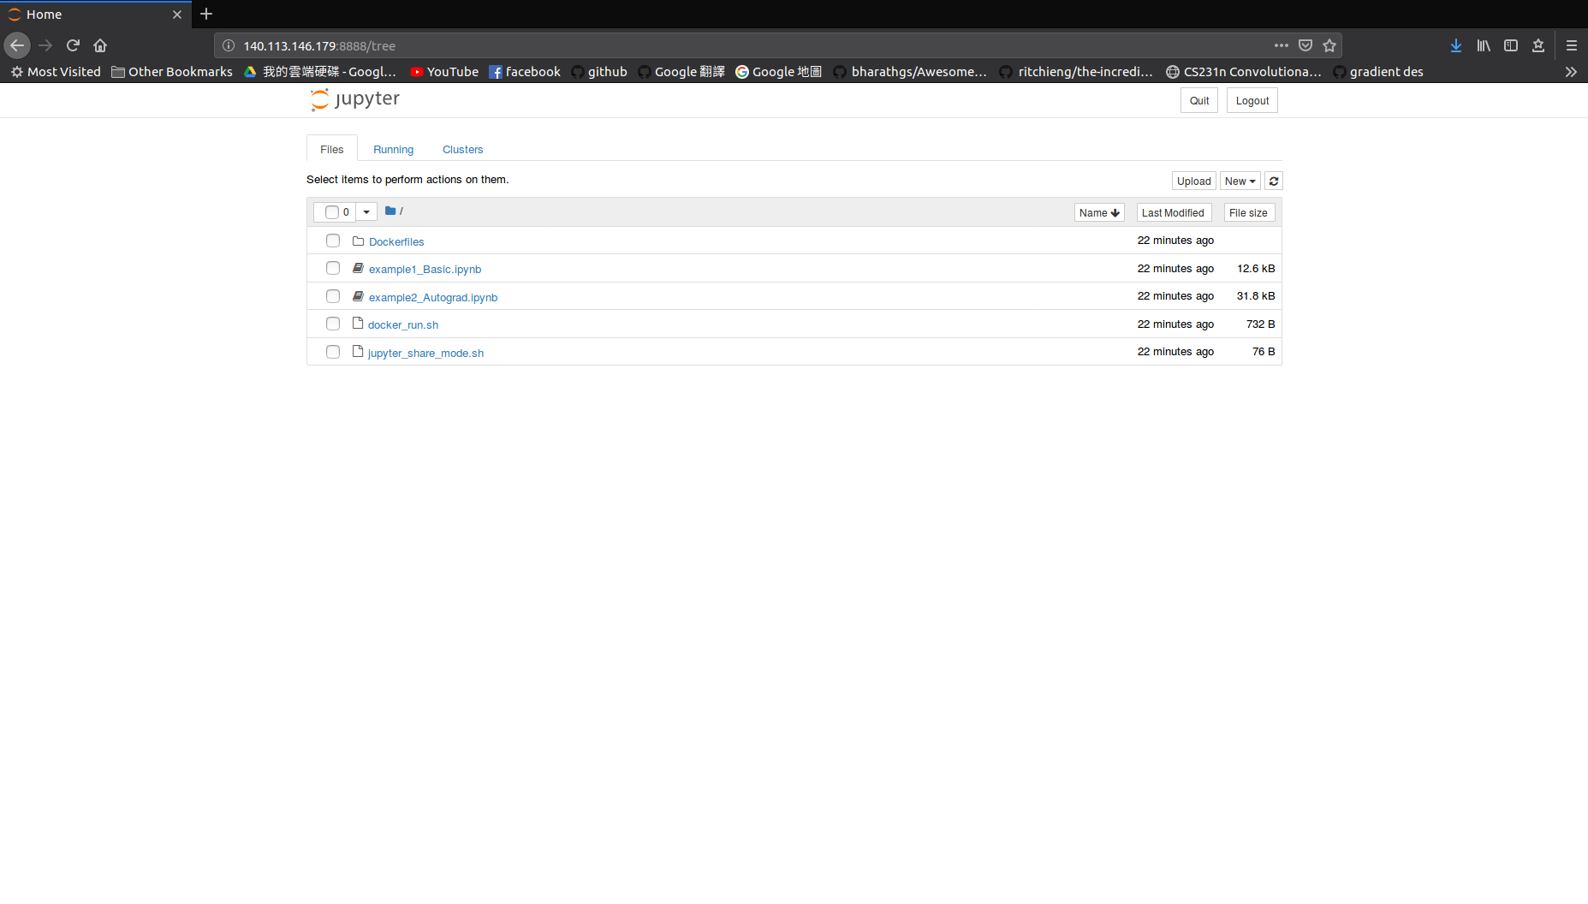

**Lab 11: Deep Learning Tutorial 3** **1**

Hardware and Software Setup 1

Overview 2

Usage of jupyter notebook 3

[Topics and Activities](https://docs.google.com/document/d/1nwBQqytVoV3N-tVW9Ve2-gO8_ynVhsVRH0YZjLsRi_I/edit#heading=h.g0fw0bgwxhdt) [3](https://docs.google.com/document/d/1nwBQqytVoV3N-tVW9Ve2-gO8_ynVhsVRH0YZjLsRi_I/edit#heading=h.g0fw0bgwxhdt)

Topic/Activity 1 Introduction to CNN 3

[Topic 1.1 Dataset loader](https://docs.google.com/document/d/1nwBQqytVoV3N-tVW9Ve2-gO8_ynVhsVRH0YZjLsRi_I/edit#heading=h.rl15slrm10vt) [4](https://docs.google.com/document/d/1nwBQqytVoV3N-tVW9Ve2-gO8_ynVhsVRH0YZjLsRi_I/edit#heading=h.rl15slrm10vt)

Topic 2.1 Label Your Data 4

**Assignment.** **8**

Reference 8

## Overview

Estimated Time to Finish: 1.5 hours

After completing this tutorial you should

* know the complete process to load, train data and evaluate your model with test data.
* understand how to use Labelme to label data.

## Usage of jupyter notebook

1. Keyboard shortcuts: (Help → Keyboard shortcuts)  
   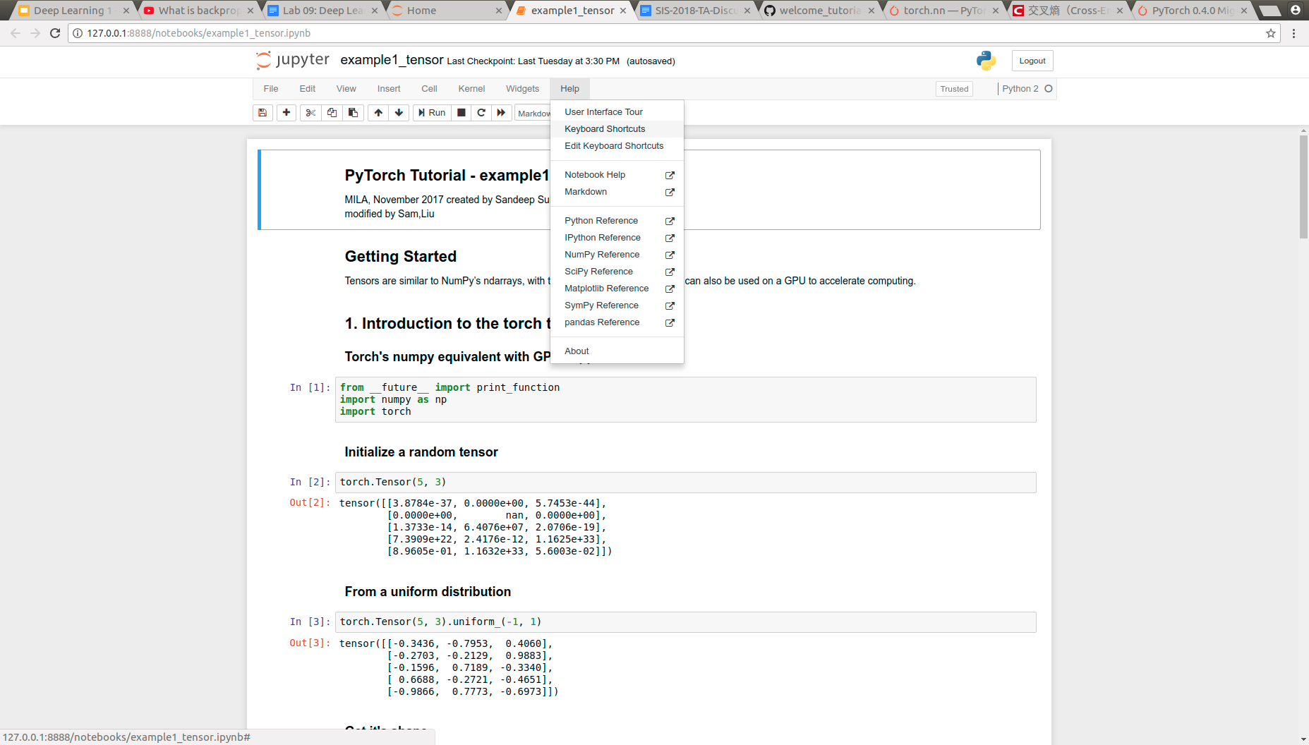
2. Run cell: [Shift+Enter]
3. 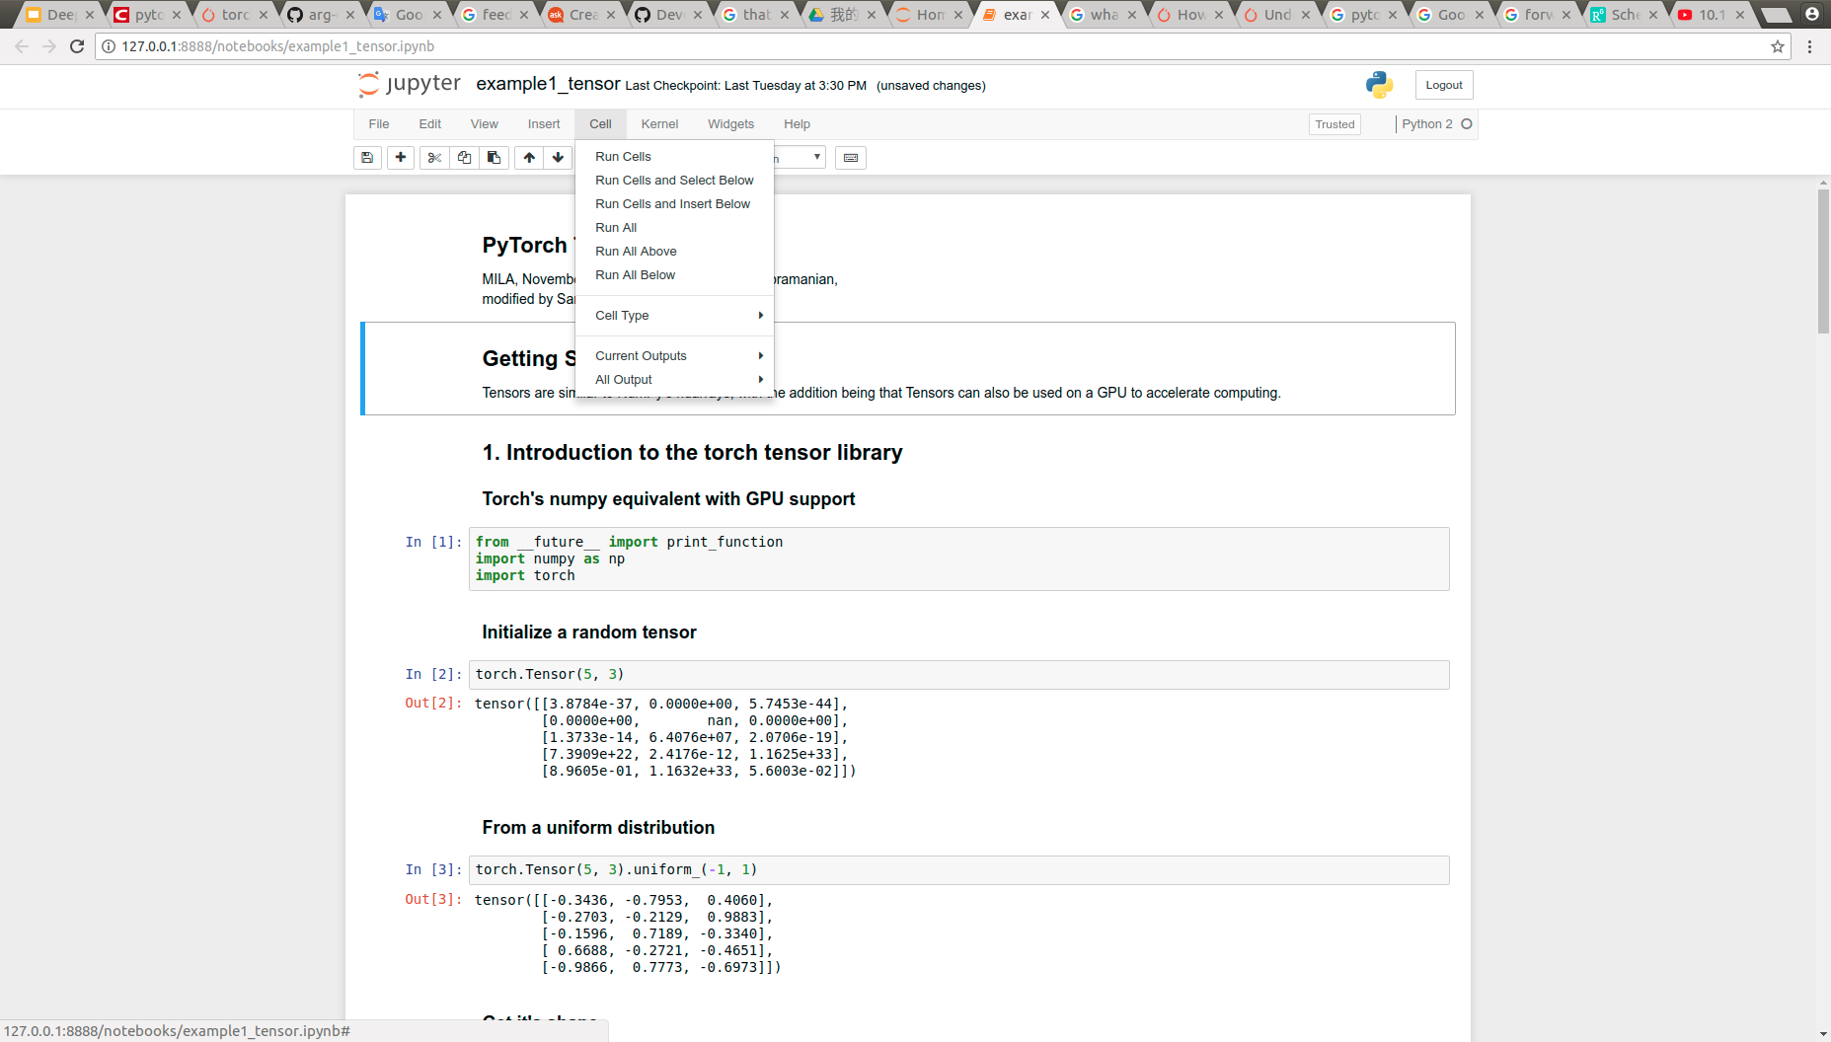

## 

## Topics and Activities

### Topic/Activity 1 ImageFolder and training pipeline

**Note:** Load pretrained model from google drive first. ‘gdown’ is a tool let user download file from google drive directly.

Enter the course material directory: sis_lab_all_2020/13-Deep_Learning_3/

**container $ pip install gdown**

**container $ gdown --id 1HOSHcp2Kvdv7wTmfa3Kwcrcs-iMas9fa**

Wait a moment, you will see ‘_iter_10000.pth’ file in the same directory

**container $ source jupyter_no_broswer.sh**

Then turn on jupyter notebook, and click **pytorch_dataloader_example.ipynb**

**Discussion.**

1. If you need to use function “ImageFolder” to load dataset, what format does the dataset need to follow?
2. If the model is accurate, How does the confusion matrix look like?
3. Could you briefly talk about what do you need to do before training the data?

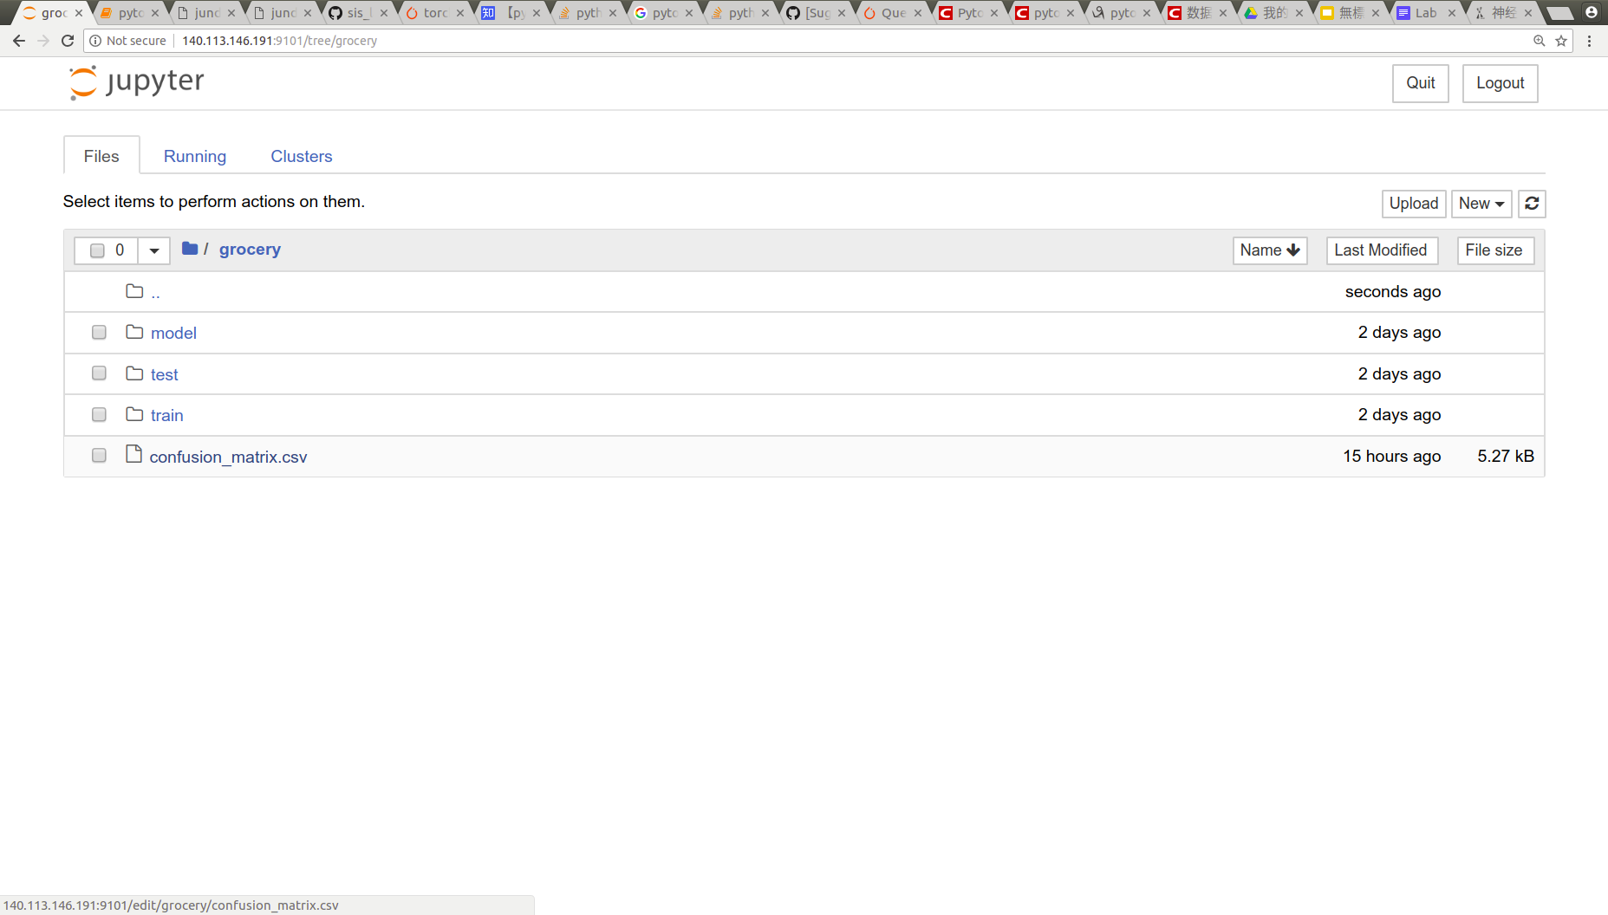(1) 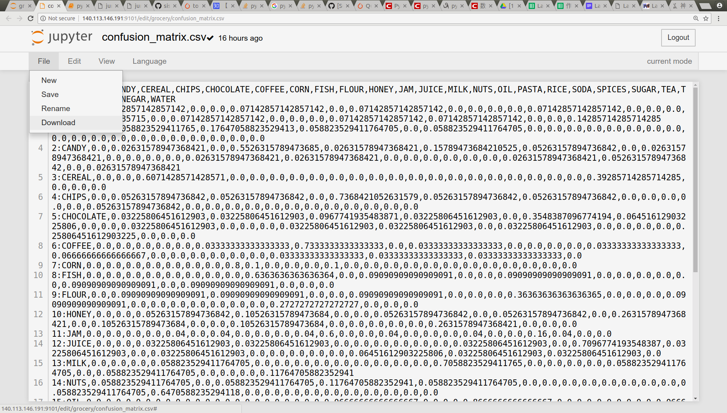(2)

To output the confusion matrix, check the folder ‘grocery’ then you download it to your computer.

#### Topic/Activity 2. Label Your Data

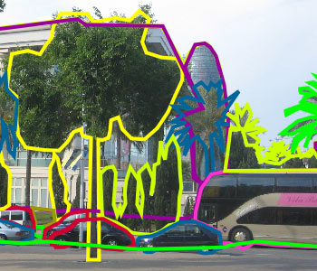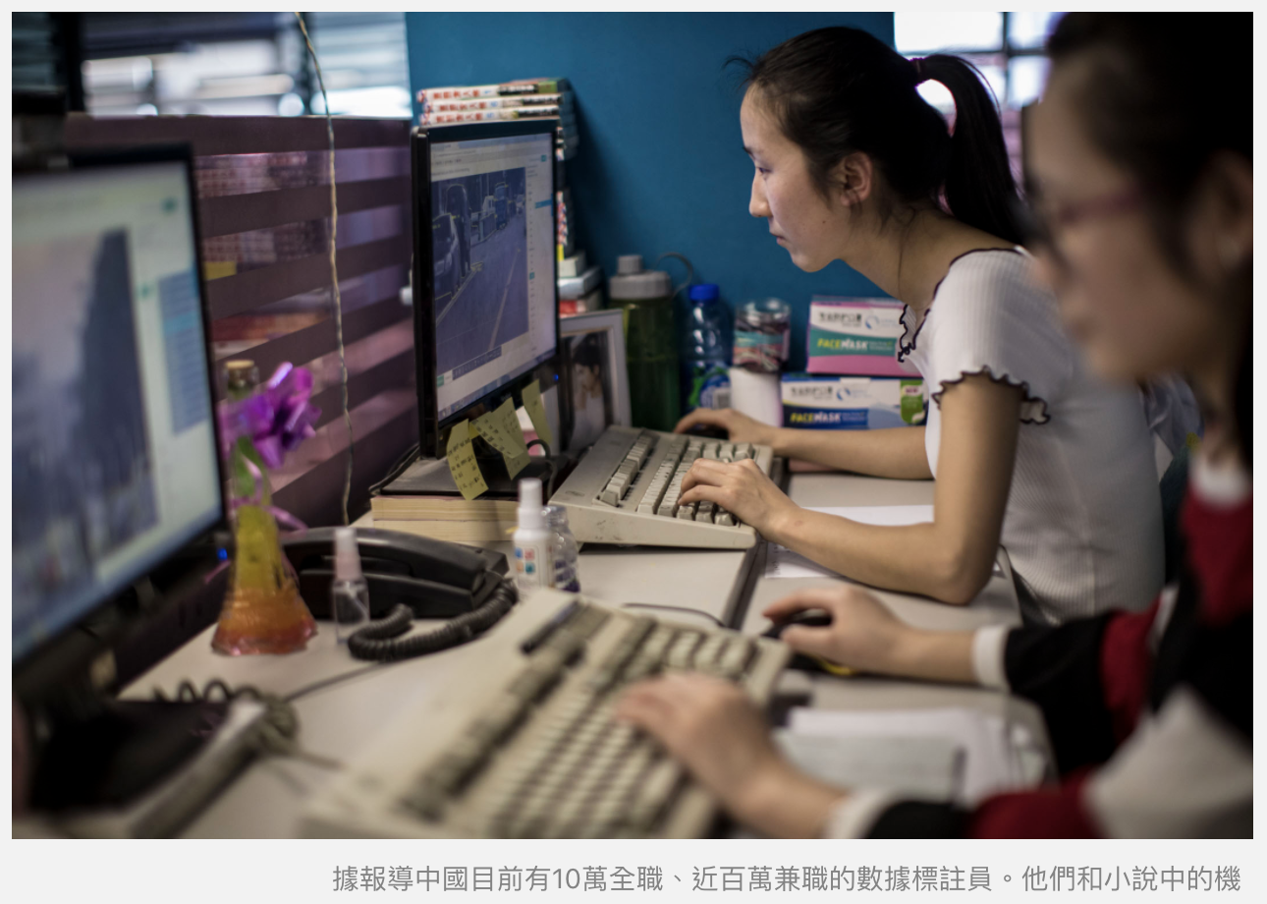

The purpose of this activity is labelling training data from images by LabelMe platform.

1) Enter the following link which consists of placard images with the account. There are one groups of images which will be used for mini competition. Labelme link:

<http://labelme2.csail.mit.edu/Release3.0/browserTools/php/browse_collections.php?public=&username=argrobotx&folder=/>

Account

account: sis2020

password: sis2020

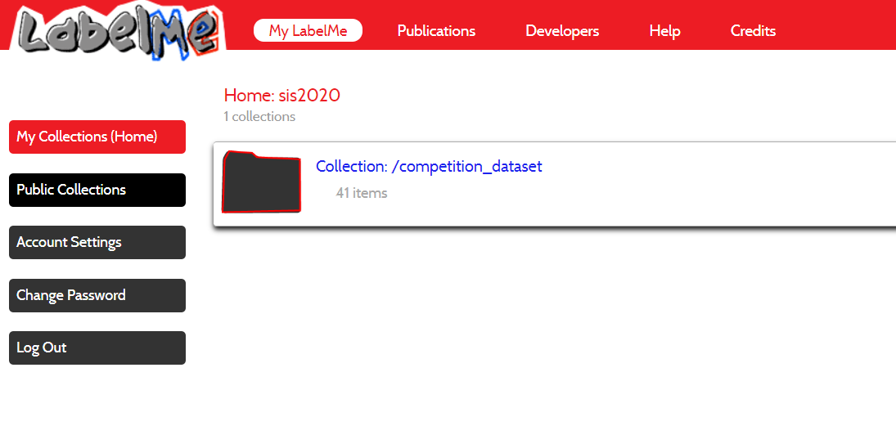

2) Click into “Collection: /competition_dataset” → “Collection: /competition_dataset/scene_000000” and click one of a image”

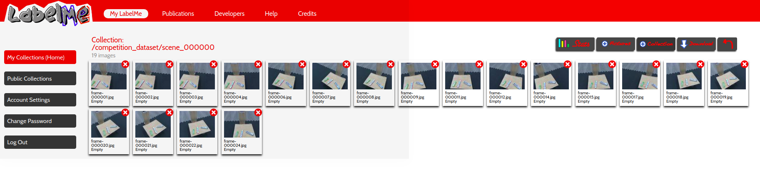

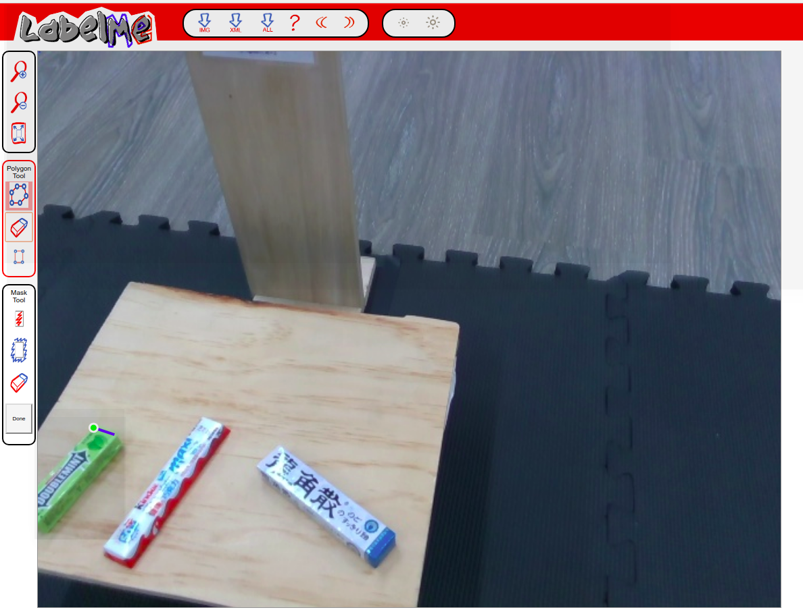

3) Click “change user” on right-top and enter your name

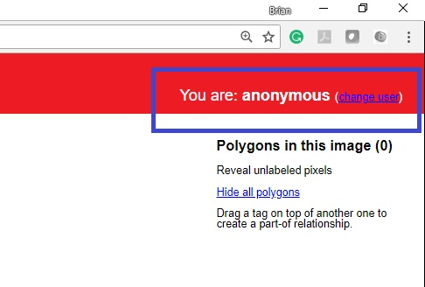

4) Label the object. The labels should be consistent among all annotators. In these two collections, our object list are:

* doublemint
* kinder
* kusan

1. click the "Start polygon" icon to label the object



1. select the polygon point (tightly enclose the object)

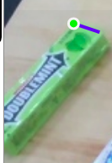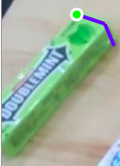 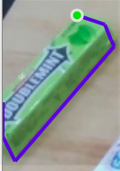

1. add the object name and click “Done”

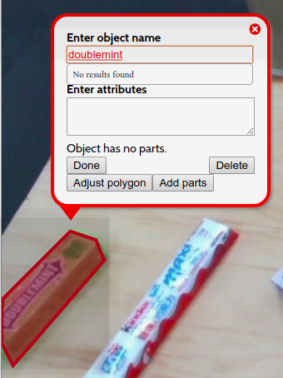

5) After finishing the labelling, download “images” and “annotations.” Go back to the “Collection: /competition_dataset/scene_0000XX” page and click “Download.” Check the "images" and “annotations.”

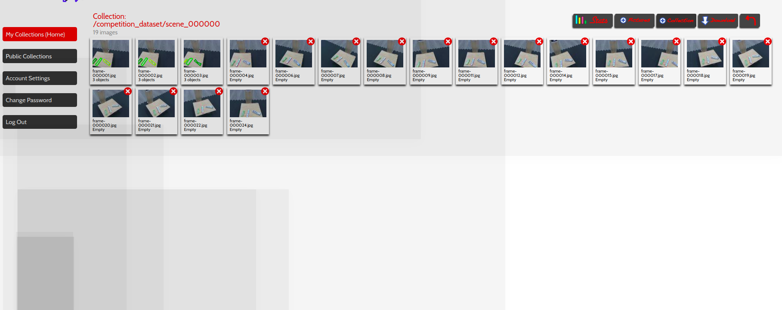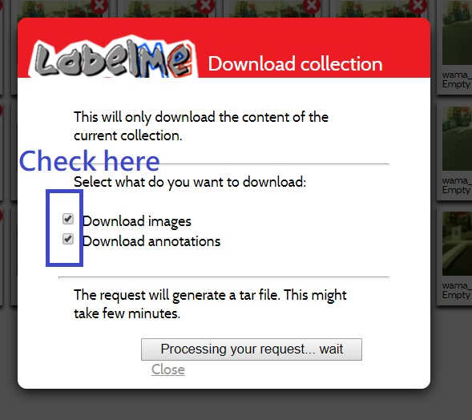

6) In the download file, there are two folders: “Images” and “Annotations.” The “Images” folder consists of the images of the collection folder you download. And “Annotations” folder includes the labelling information. Click the “Annotations\users\sis2020\competition_dataset\scene_0000XX” file and you can see the labeling information we did in step 4)

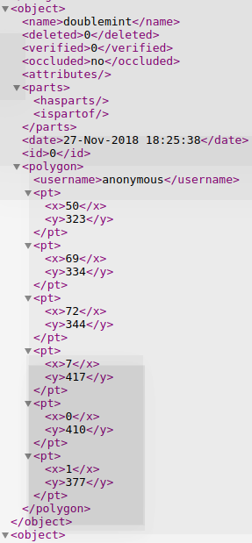

Samples

|  |  |
| --- | --- |
| Good label | Bad label |
|  |  |

**Discussion**

1. Everyone is assigned to label one of a scene to label. Please practice labeling 5 images and show the label to TA. You can get your own scene by browsing the [table](https://docs.google.com/spreadsheets/d/1kKMtK-qN-NLCXszjWlOBw4a32k2cid6uvbMSV1zjI3o/edit#gid=0).

# Assignment.

Before 6/7 23:59, you need to finish labeling all images in the scene.

## Reference

Pytorch official tutorial: <https://pytorch.org/tutorials/>

Mila-udem pytorch tutorial: <https://github.com/mila-udem/welcome_tutorials/tree/master/pytorch>